Q1.

models.py

from django.db import models

class Category(models.Model):

name = models.CharField(max_length=255)

number_of_visits = models.IntegerField(default=0)

number_of_likes = models.IntegerField(default=0)

def __str__(self):

return self.name

class Page(models.Model):

category = models.ForeignKey(Category, related_name='pages', on_delete=models.CASCADE)

title = models.CharField(max_length=255)

url = models.URLField()

views = models.IntegerField(default=0)

def __str__(self):

return self.title

views.py

# directory/views.py

from django.shortcuts import render, redirect

from .models import Category, Page

from .forms import CategoryForm, PageForm

def home(request):

categories = Category.objects.all()

return render(request, 'directory/home.html', {'categories': categories})

def add_category(request):

if request.method == 'POST':

form = CategoryForm(request.POST)

if form.is_valid():

form.save()

return redirect('home')

else:

form = CategoryForm()

return render(request, 'directory/add_category.html', {'form': form})

def add_page(request):

if request.method == 'POST':

form = PageForm(request.POST)

if form.is_valid():

form.save()

return redirect('home')

else:

form = PageForm()

return render(request, 'directory/add_page.html', {'form': form})

add_category.html

<!DOCTYPE html>

<html>

<head>

<title>Add Category</title>

</head>

<body>

<h1>Add Category</h1>

<form method="POST">

{% csrf_token %}

{{ form.as_p }}

<button type="submit">Add Category</button>

</form>

<a href="{% url 'home' %}">Back to home</a>

</body>

</html>

add_page.html

<!DOCTYPE html>

<html>

<head>

<title>Add Page</title>

</head>

<body>

<h1>Add Page</h1>

<form method="POST">

{% csrf_token %}

{{ form.as_p }}

<button type="submit">Add Page</button>

</form>

<a href="{% url 'home' %}">Back to home</a>

</body>

</html>

home.html

<!DOCTYPE html>

<html>

<head>

<title>Website Directory</title>

</head>

<body>

<h1>Website Directory</h1>

<h2>Categories</h2>

<ul>

{% for category in categories %}

<li>

<h3>{{ category.name }} ({{ category.number_of_visits }} visits, {{ category.number_of_likes }} likes)</h3>

<ul>

{% for page in category.pages.all %}

<li><a href="{{ page.url }}">{{ page.title }}</a> ({{ page.views }} views)</li>

{% endfor %}

</ul>

</li>

{% endfor %}

</ul>

<a href="{% url 'add_category' %}">Add Category</a><br>

<a href="{% url 'add_page' %}">Add Page</a>

</body>

</html>

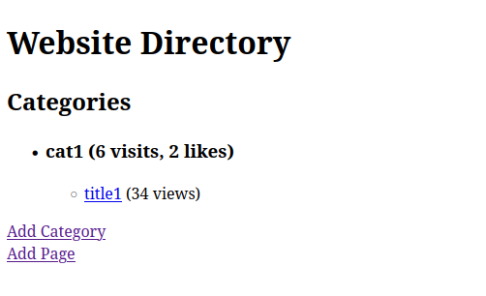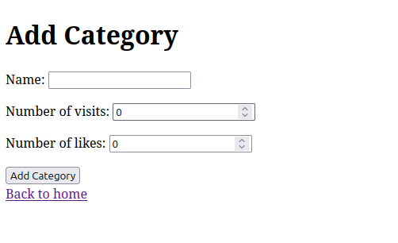

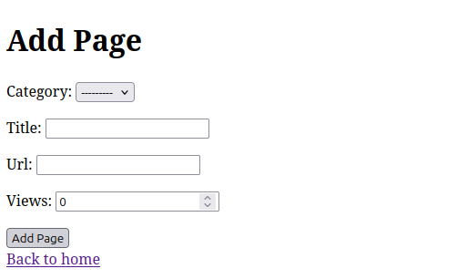

Q2.

models.py

from django.db import models

class Works(models.Model):

person_name = models.CharField(max_length=100)

company_name = models.CharField(max_length=100)

salary = models.DecimalField(max_digits=10, decimal_places=2)

def __str__(self):

return f"{self.person_name} works at {self.company_name}"

class Lives(models.Model):

person_name = models.CharField(max_length=100)

street = models.CharField(max_length=100)

city = models.CharField(max_length=100)

def __str__(self):

return f"{self.person_name} lives at {self.street}, {self.city}"

views.py

from django.shortcuts import render, redirect

from .models import Works, Lives

from .forms import WorksForm, LivesForm

def home(request):

return render(request, 'employees/home.html')

def add_work(request):

if request.method == 'POST':

form = WorksForm(request.POST)

if form.is_valid():

form.save()

return redirect('home')

else:

form = WorksForm()

return render(request, 'employees/add_work.html', {'form': form})

def add_lives(request):

if request.method == 'POST':

form = LivesForm(request.POST)

if form.is_valid():

form.save()

return redirect('home')

else:

form = LivesForm()

return render(request, 'employees/add_lives.html', {'form': form})

def find_people(request):

if request.method == 'POST':

company_name = request.POST.get('company_name')

people = Works.objects.filter(company_name=company_name)

result = []

for work in people:

city = Lives.objects.filter(person_name=work.person_name).first()

if city:

result.append({'person_name': work.person_name, 'city': city.city})

return render(request, 'employees/find_people.html', {'result': result, 'company_name': company_name})

return render(request, 'employees/find_people.html')

add_lives.html

<!DOCTYPE html>

<html>

<head>

<title>Add Lives</title>

</head>

<body>

<h1>Add Lives</h1>

<form method="POST">

{% csrf_token %}

{{ form.as_p }}

<button type="submit">Add Lives</button>

</form>

<a href="{% url 'home' %}">Back to Home</a>

</body>

</html>

home.html

<!DOCTYPE html>

<html>

<head>

<title>Home</title>

</head>

<body>

<h1>Welcome to the Employee Directory</h1>

<ul>

<li><a href="{% url 'add_work' %}">Add Work</a></li>

<li><a href="{% url 'add_lives' %}">Add Lives</a></li>

<li><a href="{% url 'find_people' %}">Find People</a></li>

</ul>

</body>

</html>

find_people.html

<!DOCTYPE html>

<html>

<head>

<title>Find People</title>

</head>

<body>

<h1>Find People Working for a Company</h1>

<form method="POST">

{% csrf_token %}

<label for="company_name">Enter Company Name:</label>

<input type="text" name="company_name" id="company_name">

<button type="submit">Search</button>

</form>

{% if result %}

<h2>People working for {{ company_name }}:</h2>

<ul>

{% for person in result %}

<li>{{ person.person_name }} - {{ person.city }}</li>

{% endfor %}

</ul>

{% endif %}

</body>

</html>

add_work.html

<!DOCTYPE html>

<html>

<head>

<title>Add Work</title>

</head>

<body>

<h1>Add Work</h1>

<form method="POST">

{% csrf_token %}

{{ form.as_p }}

<button type="submit">Add Work</button>

</form>

<a href="{% url 'home' %}">Back to Home</a>

</body>

</html>

